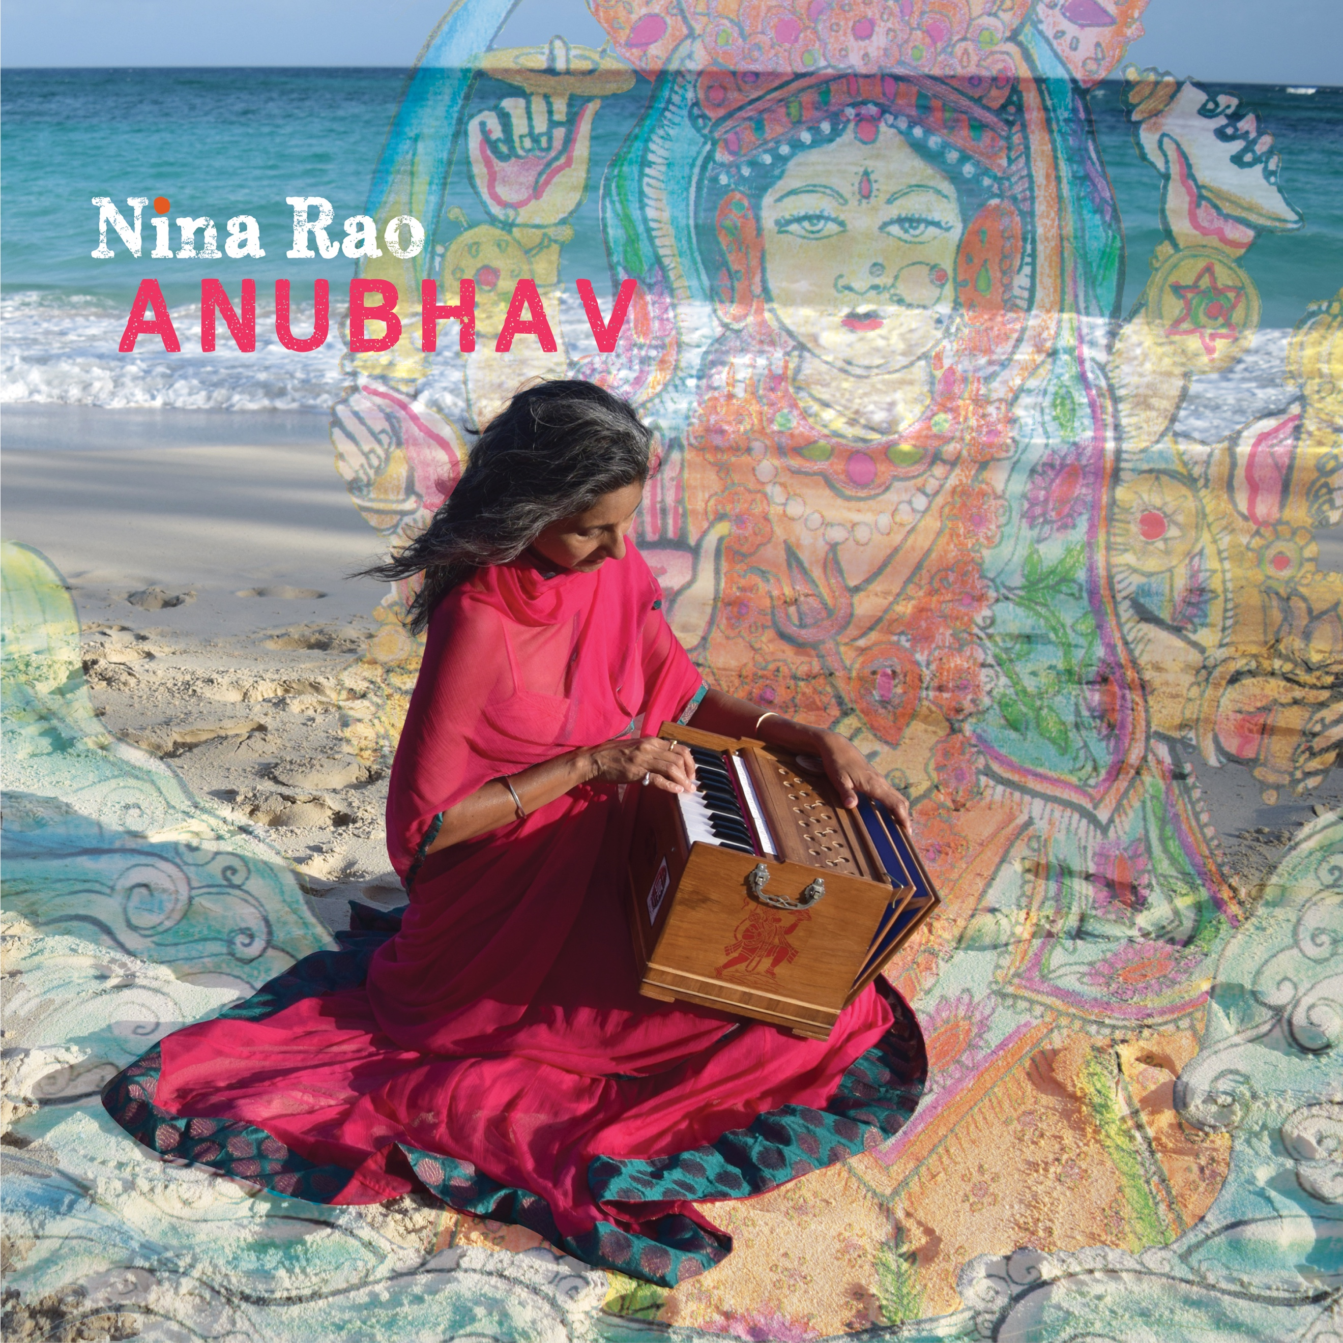
Artist: Nina Rao
Album: Anubhav
Label: Rare Earth Explorations
UPC: 700261468662

Category: New Age
“Anubhav” immerses the listener and chant practitioner in deep invocational prayers and upbeat kirtan and bhajan from the Indian tradition. Lush instrumentation of strings and drums from the western world meld with Indian instruments - harmonium, veena, bansuri, tabla, dholak, ghatam, kartals - as well as earthy instruments of Africa and Brazil, the kora and berimbau. When Nina calls, the choir responds in support of this ancient spiritual practice. The album (of course) includes a new rendition of the Hanuman Chalisa but also the new addition of a Buddhist chant. As the melodies pull us deep and lift us to the sky of the heart, the voices of guest artists Krishna Das, MC YOGI, Trevor Hall, and her daughter Uma, bridge the old with the new and Present.
Nina Rao first learned traditional chants from her grandfather as a young girl while on summer holiday in a village in south India. The chants quietly stayed with her until she rediscovered chanting with Krishna Das in New York in 1996. Her first studio release is the track 'Nina Chalisa' on Krishna Das' CD "Flow of Grace - Chanting the Hanuman Chalisa" released in 2007. By popular demand from those who chant live with Nina, she released her debut double-CD album “Antarayaami – Knower of All Hearts” in January 2013 that has become a ‘classic’ for many chant listeners. Five years later, she has released her second album “Anubhav”. Nina continues to manage Krishna Das’s business and tours with him, and also leads kirtans, workshops, and retreats of her own.
Anubhav Track List
1 Satguru Deva
2 Amma Sita Ram
3 Shiva Maheshwara
4 Ramaya Sri Ram Vandana
5 Ramaya Hanuman Chalisa
6 Ramaya Sri Ram Jai Ram
7 Tashi Lama Chenno
8 Devi Pranamah
9 Jai Ma
10 Govinda Gopala
11 Govinda Jaya Jaya

