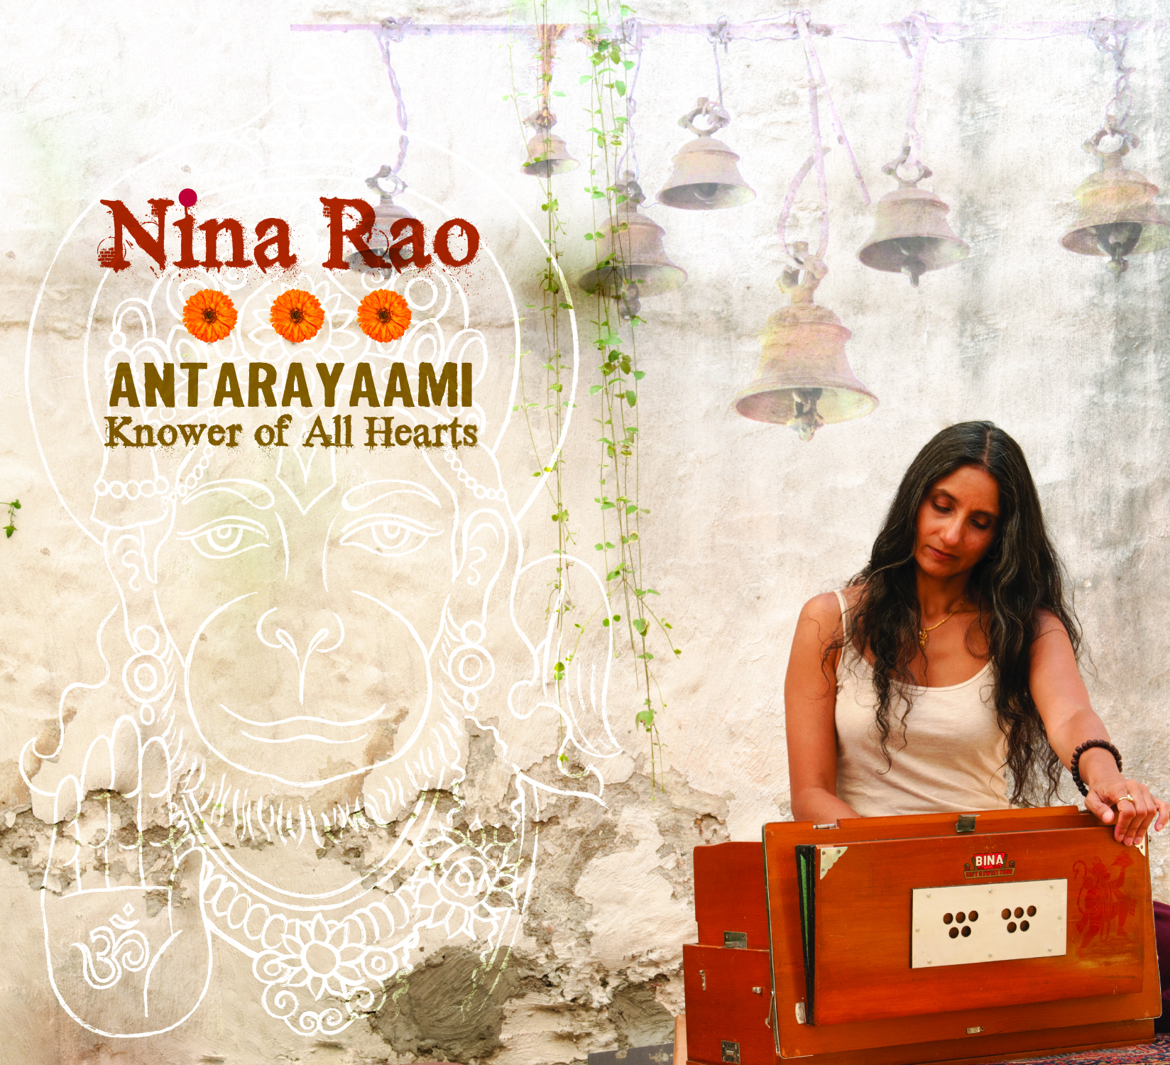 | Nina Rao  Antarayaami -  Knower of All Hearts  Label: Rare Earth Explorations  UPC: 700261373331  Category: New Age

“Antarayaami – Knower of All Hearts” by Nina Rao offers the practice of chanting born from her South Indian roots and influenced by her many years of chanting in the USA. This 12-track double-CD of call-and-response kirtan and Hanuman Chalisa melodies including a duet with Grammy-nominated new age artist, Krishna Das, blends the sacred sounds of traditional eastern tabla, dholak, harmonium, kartals, bansuri flute, esraj, and sarod with Western electric bass, violin, guitar and banjo, and soulful vocals. This album draws from the rich heritage of devotional music and chanting style from India and is still rendered accessible for all to sing along with.

Nina Rao first learned traditional chants (bhajans) from her grandfather while on holiday in a village in south India when she was a girl of nine years. The chants quietly stayed with her until she rediscovered chanting with Krishna Das in New York in 1996. Her first studio release is the track 'Nina Chalisa' on Krishna Das' CD "Flow of Grace - Chanting the Hanuman Chalisa" released in 2007. She regularly tours with Krishna Das playing cymbals and supporting vocals, and also leads kirtan and chanting on her own.

Tracklist:  Disc One  1 Bhajagovindam Narayana (16:49)  2 Brindavan Mahamantra (13:14)  3 Saraswati Shaarade Devi (7:25)  4 Pati Hare (7:08)  5 Antarayaami (6:14)  6 Bhajagovindam (4:07) | Disc Two  - Ocean of Ram Hanuman Chalisa (10:56)  - Samadhi Hanuman Chalisa (8:32)  - Sundarakand Hanuman Chalisa (8:25)  - Nina Hanuman Chalisa (8:11)  - Uma Hanuman Chalisa (7:54)  - Vinayaka Always (7:17)  Bonus Track –  Lokah Samastah Sukhino Bhavantu (13:22)
http://www.ninaraochant.com
Distribution Contact: A-Train Entertainment
Physical: Joseph Sobocan joseph@a-train.com
Digital: Bob Williard bob@a-train.com

